Performance Development Review (PDR)
Name:
Job Title:
Line Manager:
PDR Year:

PDR’s are essential to set clear priorities which align with our council plan, clarify expectations, recognise achievements, discuss and support development needs and provide feedback for self and team members. They help all employees feel valued, supported, and confident about how to succeed in their role and help us to be outcome focussed and deliver council priorities. This PDR template helps you keep a record of what you discussed at your PDR meeting, so you can look back at it whenever you need to. What really matters is the quality of your conversation.

You can watch a short video which explains our PDR cycle.

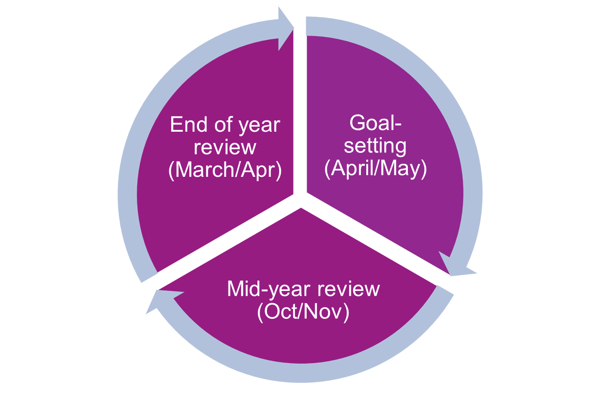

Section 1 – Goals and Behaviours
SMART goals describe WHAT we will deliver in the year ahead and our values and behaviours describe HOW we will deliver our goals.
Your SMART goals should align to your team plan, service plan and the council plan. Every employee should live our four council values by demonstrating our eight associated behaviours shown in the diagram below. Choose the behaviours that align to your goal, then use the examples shown in the behaviour framework to explain how chosen behaviours will help you achieve your goal.
Top tips​:
- You can use copilot to help make your goals SMART
- Here’s the link to the Performance Development Review Hub and Our Derbyshire with lots of useful resources
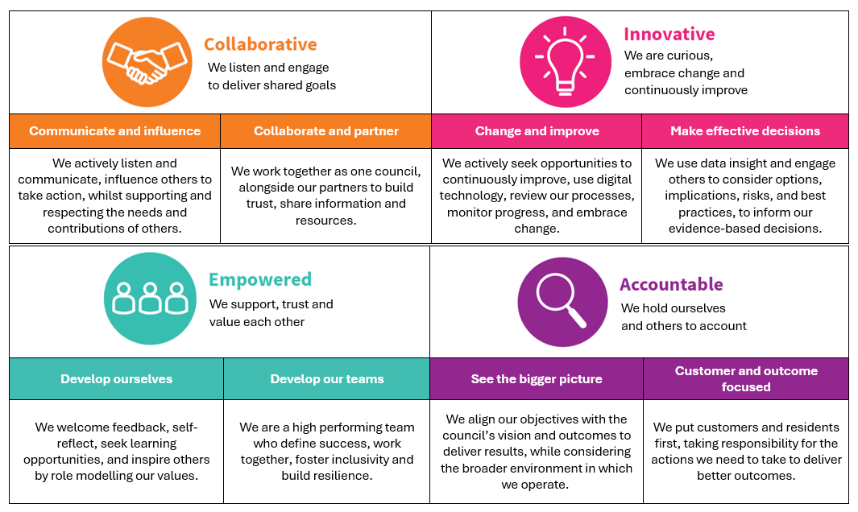

SMART GOAL 1 (max 5)

Write your high level SMART goal and list the actions required to deliver it
Describe HOW you will deliver your goal (Describe the behaviours you will use)

Describe how will you MEASURE your success? What will successful performance look like?
Mid-Year Review: Review your goal delivery progress (including the behaviours you are demonstrating)
End Of Year Review: Reflect whether you achieved your goal (including the behaviours you demonstrated)

SMART GOAL 2 (max 5)

Write your high level SMART goal and list the actions required to deliver it
Describe HOW you will deliver your goal (Describe the behaviours you will use)

Describe how will you MEASURE your success? What will successful performance look like?
Mid-Year Review: Review your goal delivery progress (including the behaviours you are demonstrating)
End Of Year Review: Reflect whether you achieved your goal (including the behaviours you demonstrated)

SMART GOAL 3 (max 5)

Write your high level SMART goal and list the actions required to deliver it
Describe HOW you will deliver your goal (Describe the behaviours you will use)

Describe how will you MEASURE your success? What will successful performance look like?
Mid-Year Review: Review your goal delivery progress (including the behaviours you are demonstrating)
End Of Year Review: Reflect whether you achieved your goal (including the behaviours you demonstrated)

SMART GOAL 4 (max 5)

Write your high level SMART goal and list the actions required to deliver it
Describe HOW you will deliver your goal (Describe the behaviours you will use)

Describe how will you MEASURE your success? What will successful performance look like?
Mid-Year Review: Review your goal delivery progress (including the behaviours you are demonstrating)
End Of Year Review: Reflect whether you achieved your goal (including the behaviours you demonstrated)

SMART GOAL 5 (max 5)

Write your high level SMART goal and list the actions required to deliver it
Describe HOW you will deliver your goal (Describe the behaviours you will use)

Describe how will you MEASURE your success? What will successful performance look like?
Mid-Year Review: Review your goal delivery progress (including the behaviours you are demonstrating)
End Of Year Review: Reflect whether you achieved your goal (including the behaviours you demonstrated)

Section 2 – Career Aspirations
You might want to take a bit of time to think about where you’d like your career to go—both in the near future and further down the line—and chat it through with your manager. These conversations help them understand what you’re aiming for so they can offer the right support, opportunities, and development. It also helps the council plan ahead by matching people’s strengths and aspirations with future needs.
Your career goals might be about growing in your current role, or you might be thinking about moving into something new or taking your work in a different direction.

What would you like to achieve in your career in next 12-18 months?

What would you like to achieve in your career in the next 18 months to 3 years?
Aspirations |  | Please tick one of options
Aspirations | Develop in current role
Aspirations | Aspiring to change role/direction
Aspirations | Develop to higher grade in 12-18 months
Aspirations | Develop to a higher grade in 18 months - 3 years

Section 3 – Personal Development Plan
Personal development is the ongoing process of growing in your role. It helps you identify the skills and behaviours you need to achieve your goals, progress your career, and strengthen your team’s capability.
This section should be used as a live document and updated in regular 121s or supervisions.
Top tips​:
- The Leadership Learning Zone has a range of tools and resources to help you develop your people management skills, grow your confidence and succeed in your role.
- You can find useful personal development activities on Derbyshire Learning Online .
- Here’s the link to the Performance Development Review Hub and Our Derbyshire with lots of useful resources.

Development Goal  Write your development goal | Development Activity  How are you going to achieve your development goal? | Support  What support will you need? | Success criteria  How will you know you have been successful? | Target Date | Status  (not started/ in progress / complete

Section 4 – Feedback
We want you to feel excited about your growth and confident in developing your skills as a leader. One of the most powerful ways to do that is by being open to feedback. Think of feedback not as criticism, but as a gift that helps you become the very best version of yourself.
Here’s why:
- Feedback helps us see things we might miss. Others can spot things in how we work or communicate that we may not notice. This helps us understand what we’re good at and what we can improve.
- It helps build better relationships. Asking for feedback shows that we are open and that we value other people’s views. It encourages honest conversations that help everyone.
- Feedback helps us grow. It allows us to learn, adapt, and improve the way we work. Even small suggestions can make a big difference.
This is why asking for feedback is an important part of your development as part of the PDR and through regular 1-1 or supervision conversations. We suggest choosing three to five people, including your manager, colleagues, team members, partners, and customers.
Top tips​:
- we’ve created an email template you can use/adapt when asking for feedback
- You can find helpful information on how to give and receive useful feedback on our feedback guide
- Here’s the link to the Performance Development Review Hub and Our Derbyshire with lots of useful resources

Feedback from key stakeholders

What do I do when I’m at my best? (Note the date you received feedback, who from and a summary of feedback received)

Date | Who | Feedback
What could be my ‘Achilles heel’ that could prevent me from reaching my potential? (Note the date you received feedback, who from and a summary of feedback received)

Date | Who | Feedback
What could I do differently as a result of this feedback? (This could link to your personal development plan)

Section 5 – End Of Year Review
Your end of year review meeting is a great chance to look back over your full PDR and reflect on how the year has gone—what you achieved, how you achieved it, the progress you’ve made toward your career aspirations, the development you’ve undertaken, and the feedback you’ve received from others.

This section is your space to bring everything together and summarise how you feel the year went overall. It’s an opportunity to step back, recognise your growth, and capture the key moments that shaped your year.

 | Comments | Date
My summary

Line Manager’s summary

Copy of this form to be stored in HR Files (EDRM) and be used as a working document throughout the PDR year.

