**Nissan Leaf - Quick Start Guide**

**Starting**

* 1. Unlock the car with the key or button on front door handle
  2. Sit in the car and ensure that the key is in the front near to the steering wheel
  3. DEPRESS the brake pedal + PRESS the power button (left of the steering wheel).

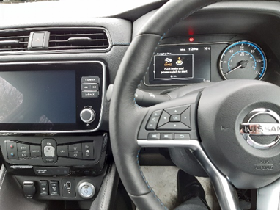

* 1. Check that the “READY to drive” indicator light illuminates (green car):

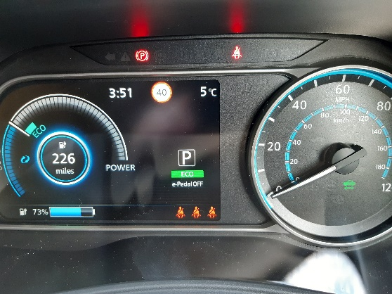

* 1. Check that the PARKING BRAKE lever is up (red LED on) and that the vehicle is in PARK (P displayed on dash).

**Get Ready to Drive**

1. Conduct your pre-drive check – items such as Lights, Tyres, Mirrors and glass should be checked for any defects. Check the condition of the interior and exterior of the vehicle. Check that the battery level is sufficient for your journey. Check the steering by moving your steering wheel from lock to lock – listen out for any noises and feel for any play. Report any defects back to Ian Slackfor rectification.
2. DEPRESS and hold the brake pedal
3. Press the PARKING BRAKE lever down – red LED turns OFF

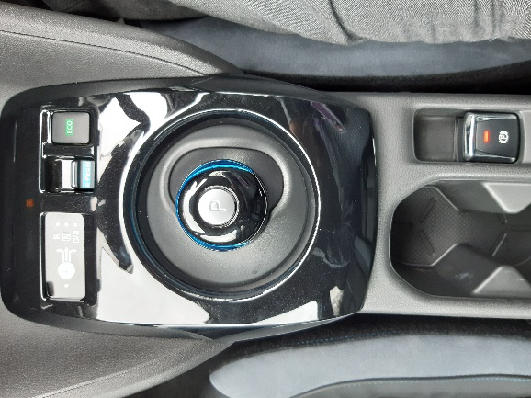

1. Shift the gearstick lever to select desired driving mode as per table below:

|  |  |
| --- | --- |
| **Driving Mode** | **Action Required** |
| Park | Press “P” button on top of the gear stick |
| Neutral | Shift gear stick RIGHT |
| Reverse | Shift gear stick RIGHT + FORWARD |
| Drive (forward) | Shift gear stick RIGHT + BACK (Once) |
| B (forward) | Shift gear stick RIGHT + BACK (Twice). *When the B position is used, regenerative braking is applied when the accelerator pedal is released*. |

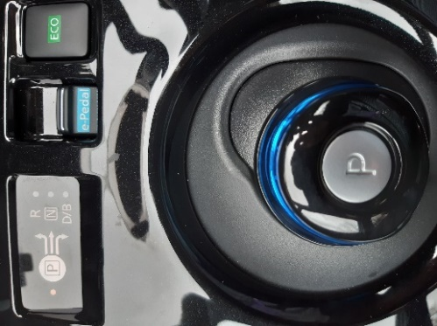

5. Check on dashboard that correct gear has been selected.

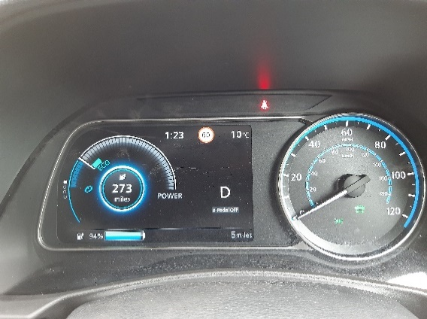

**Driving Range**

1. The maximum driving range given by the manufacturer is approximately 239 miles per full charge. Real world driving under normal conditions would give you 160-170 miles. The driving range is affected by driving style, traffic jams and weather conditions i.e. use of lights, wipers and heaters.
2. To maximise your range, use the car in B mode, activate the “Eco” mode and drive cautiously.
3. To use Eco mode – press the Eco button next to the gearstick lever. A light will illuminate on the dashboard below the gear select symbol indicating that Eco mode is active. Press again to turn off.

**Parking**

1. When you are ready to park the car, press the “P” button on the gearstick.
2. Lift the “Parking Brake” lever to engage the parking brake – the red LED comes ON.

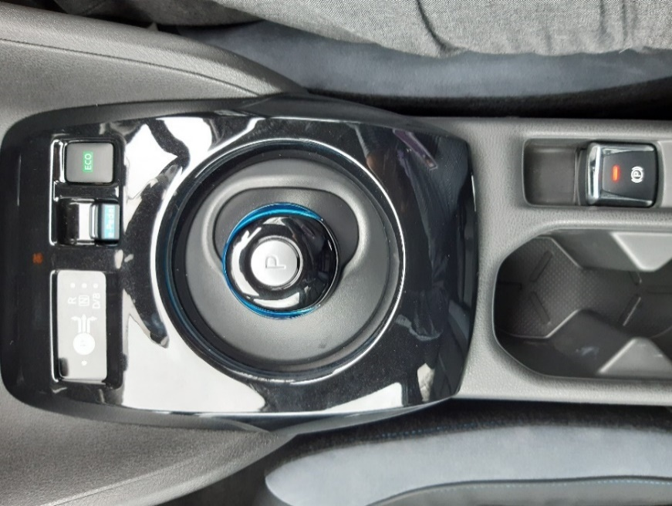

**Charging**

1.To open up the charge port lid, either press the button to the right of steering wheel OR use the charge port button on the vehicle key.

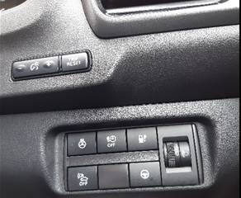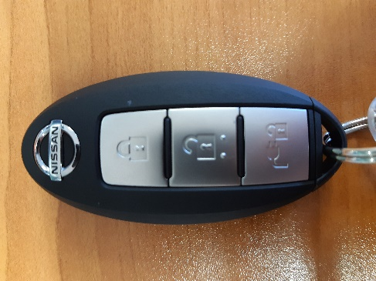

1. Lift the charge port lid at the front of the bonnet.

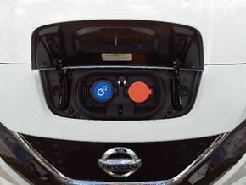

1. Connecting the charging cable to the car;

Both cables are stored in the boot of the car. Check the cables for any damage. If any damage is found, do not use and contact Ian Slack for advice.

The **blue** connection port is for quick-charge (found at some service stations/supermarkets etc), whereas the **red** connection port is for standard Mode-3 (County Offices) *OR* EVSE 240v (Home) charging cable. For the two cables supplied with the car you will be using the **red** connection port. Be sure that the charging cable is locked into the charge point.

1. Connect the other end of the charging cable to the charging station (County Offices)

*OR* the 240v wall socket (Home). **Do not use an extension cable or plug adapter.**

1. Follow the instructions on the charging station (County Offices) – tap the charge card on the panel to start the charging process (the charge card is attached to the vehicle keys in a plastic holder)

*OR*

Switch on the EVSE 240v charging cable at the wall socket. The LED lights on the EVSE 240v cable control box should light green for ready and then orange to indicate that it has power and is charging. Please use the attached EVSE Quick Reference guide if the light sequence differs as there may be a fault. Please contact Ian Slack if any faults are found.

1. The three blue lights on the vehicle dashboard will illuminate to indicate a secure connection. The blue lights correspond to its charge status. The first light flashes indicating 0-33%, the second 34-66% and the third 67-100%. Once all three lights are lit solidly, the battery level has reached 100%.
2. When the battery reaches 100%, the Nissan LEAF stops charging on its own. To end charging at any point, just unplug the charge connector.
3. Firstly, remove the end of the charge cable from the charge station or wall socket.
4. To unplug the charge cable from the car, press either the button to the right of the steering wheel or the button on the key.
5. Store the cable/s back into the boot of the car. The EVSE 240v charging cable should be stored in the bag supplied. Please store both cables in the boot nets.

**Please refer to the owner’s manual situated in the cars glove box for more information, or the attached Electric Vehicle Supply Equipment (EVSE) Quick Reference guide sheet.**

**VMS**

Your Nissan Leaf is fitted with a Vehicle Management System. This consists of vehicle telematics, driver ID, driver behaviour bar, pre-drive check function, a dash camera and a panic button.

To the right hand side of the steering wheel you will see a Driver ID receiver, a **Green** Pre-Drive check button, and a covered **Red** Panic Button.

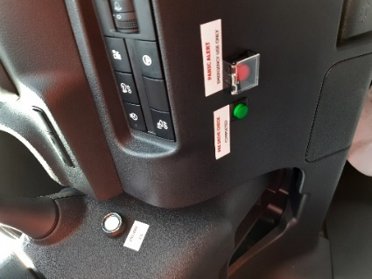

The **Green** button is to be pressed to confirm that a pre-drive check has been completed.

If you require emergency assistance then you press the **Red** panic button. This sends an alert to the system which will notify a call centre agent or a manager who will then attempt to contact you. **In an emergency situation please dial 999**

The dash camera records data in three minute sections. Once the memory of the camera is full, it will begin to over write this data. If the camera senses that there has been an impact, the current three minute time slot of data will be saved onto the memory card and cannot be overwritten. If you are involved in or witness an incident that you wish to save for future reference, press the red button located on the left hand side of the camera. This again will save the current three minutes of data on the card where it cannot be over written. If you are involved in an incident and require the camera footage to be downloaded, please speak to Ian Slack.

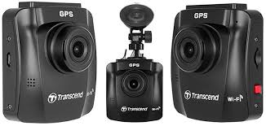

The driver behaviour bar indicates your driving performance. Green lights are great, amber indicates that you need to be more aware of your driving pattern, red indicates that you need to improve your driving style.

